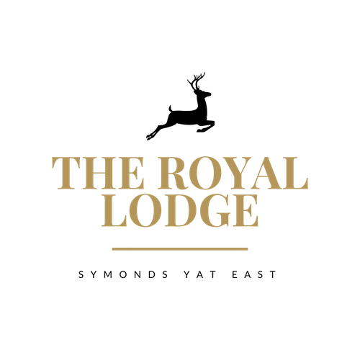

SNACK MENU

Walkers Lunch: Soup of the day and choice of sandwich (W) | £17.95
Sandwiches £12.95

Pastrami & Cheese, Djon Mustard, Gem Lettuce (W, M, Mu)
Cheese & Pickle, Gem lettuce (W, M)
Tuna Mayonnaise, Cucumber (F, M, W)
Baked Ham & Tomato, Gem lettuce (W)
Roast Chicken Salad (W)
Vegan Meatball & Cheese (W)
Coronation Chickpea, Gem lettuce (W)

Choice of Brown, White or Gluten Free Bread, £1.00 surcharge for gluten free.
Served with Coleslaw and a Handful of Plain Crisps.

ALLERGENS:
C=Celery, L=Lupin, N=Nut, Sul=Sulphur Dioxide, Cr=Crustacean, M=Milk, So=Soya P=Peanut, W=Wheat, E=Egg, Mol=Mollusc, S=Sesame, V=Vegetarian, F=Fish, Mu=Mustard

An optional 10% service charge will be added to your bill

SNACK MENU

Walkers Lunch: Soup of the day and choice of sandwich (W) | £17.95
Sandwiches £12.95

Pastrami & Cheese, Djon Mustard, Gem Lettuce (W, M, Mu)
Cheese & Pickle, Gem lettuce (W, M)
Tuna Mayonnaise, Cucumber (F, M, W)
Baked Ham & Tomato, Gem lettuce (W)
Roast Chicken Salad (W)
Vegan Meatball & Cheese (W)
Coronation Chickpea, Gem lettuce (W)

Choice of Brown, White or Gluten Free Bread, £1.00 surcharge for gluten free.
Served with Coleslaw and a Handful of Plain Crisps.

ALLERGENS:
C=Celery, L=Lupin, N=Nut, Sul=Sulphur Dioxide, Cr=Crustacean, M=Milk, So=Soya P=Peanut, W=Wheat, E=Egg, Mol=Mollusc, S=Sesame, V=Vegetarian, F=Fish, Mu=Mustard

An optional 10% service charge will be added to your bill

