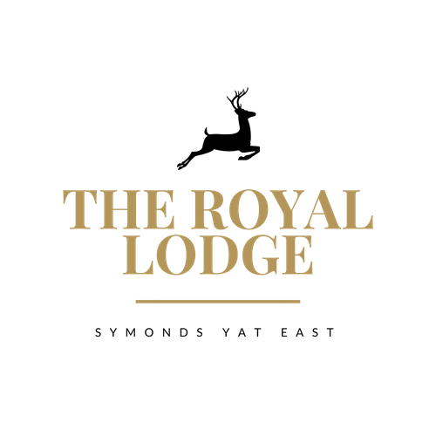

Packed Lunch Menu

Choice of Sandwich Fillings:

Choice of White or Wholemeal bread, GF available with £1 Surcharge

Pastrami & Cheese, Djon Mustard, Gem Lettuce
Cheese & Pickle, Gem lettuce
Tuna Mayonnaise, Cucumber
Baked Ham & Tomato, Gem lettuce
Roast Chicken Salad
Vegan Meatball & Cheese
Coronation Chickpea, Gem lettuce

*
Bronze (£13.95 pp)
Fresh Sandwich With Filling Of Your Choice
Packet of Pipers Crisps
Bottle of spring water
Chocolate Bar

*
Silver (£15.95 pp)
Fresh Sandwich With Filling Of Your Choice
Packet of Pipers Crisps
Piece of Fresh Fruit
Bottle of spring water
Chocolate Bar & Cake

*
Gold (£17.95 pp)
Fresh Sandwich With Filling Of Your Choice
Packet of Pipers Crisps
Piece of Fresh Fruit
Bottle of spring water
Chocolate Bar
Cake & Yoghurt

