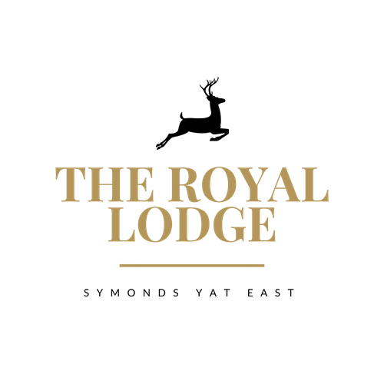

THE LODGE MENU


PRE BOOK TO RECEIVE FREE PARKING, TABLE WATER AND
COMPLIMENTARY CUP OF TEA OR FILTER COFFEE

STARTERS
Homemade Soup Of The Day, Freshly Baked Roll (W)
Chicken Tikka Terrine, Mint Yogurt, Crispy Onions (W)
Devilled Whitebait, Roasted Garlic Aioli (W)
Quinoa Falafel, Avocado Tahini Dressing (vegan)
Salt & Pepper Tofu, Coriander Pesto, Roasted Red Pepper Sauce (vegan)
MAIN COURSES
Supreme of Chicken, Mushroom, & Spinach Tagliatelle (W, M)
Pork Sausage & Plum Stuffed Loin of Pork, Thyme Roasted Baby
Potatoes, Braised Red Cabbage, Rich Pan Gravy (W, M)
Blacked Cajun Fillet of Salmon, Mango & Mint Salsa, Garlic & Lemon rice (F)
Vegan Spiced Cauliflower, Spinach & Lentil Pie, Roasted Vegetables, Mash Potatoes (Vegan)
Roasted Topside of Beef, Yorkshire Pudding, Beef Fat Roasted Potatoes, Mixed
Vegetables and Rich Lodge Gravy (W, Sul, M)

DESSERTS

Pear & Plum Crumble (M)
Chocolate & Banana Bread & Butter pudding (W, M)
Chocolate Fondant & Vanilla Ice Cream (M)
Chocolate Brownie Sundae (M)
Trio of Ice Creams with Chocolate Wafer (M)
ADULTS: 3 COURSES £39.95 2 COURSES £31.95
CHILDREN UNDER 12: 2 COURSES £22.95 (See Children’s Menu Below)

SMALL PLATES (UNDER 12)
Roasted Chicken breast, Vegetables, Mashed potatoes, Pan Gravy (M)
Cheeseburger, House chips, Heinz Baked beans or Garden Peas (W)
Duo of Sausages, Mashed Potatoes, Heinz Baked Beans or Garden Peas (M)
Battered Chicken Nuggets, House Chips, Heinz Baked Beans or Garden Peas (W)
Roasted Topside of Beef, Yorkshire Pudding, Beef Fat Roasted Potatoes, Mixed
Vegetables and Rich Lodge Gravy (W, Sul, M)

DESSERTS

Pear & Plum Crumble (M)
Chocolate & Banana Bread & Butter pudding (W, M)
Chocolate Fondant & Vanilla Ice Cream (M)
Chocolate Brownie Sundae (M)
Trio of Ice Creams with Chocolate Wafer (M)

CHILDREN UNDER 12: 2 COURSES £22.95 (See Children’s Menu Below)

Children Under 12 receive complimentary ½ pint refills on post mix cola, diet cola,
lemonade, orange and blackcurrant squash

ALLERGENS
C=Celery, L=Lupin, N=Nut, Sul=Sulphur Dioxide, Cr=Crustacean, M=Milk, So=Soya P=Peanut, W=Wheat, E=Egg, Mol=Mollusc, S=Sesame, V=Vegetarian, F=Fish, Mu=Mustard

An optional 10% service charge will be added to your bill

