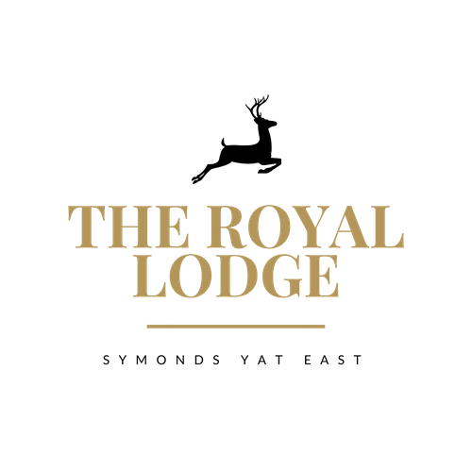
GARDEN TEA MENU
Coffee & Cake (GF, E, V)
slice of either Victoria Sponge, Chocolate Brownie or Lemon Drizzle with a Hot Beverage
£7.50

Tea & Toasted Teacakes (M, W, V)
Two Teacakes with Strawberry Jam, Butter, and a Hot Beverage
£8.95

Royal Lodge Cream Tea with Hot Beverage of Your Choice (M, W, V)
Includes two Fruit Scones, served with Clotted Cream, Strawberry or Raspberry Jam & Butter
£12.95

Sparkling Cream Tea (M, W, V)
Includes Two Fruit Scones, Served with Clotted Cream, Strawberry Jam & Butter.
Accompanied with a Hot Beverage of your choice & glass of Prosecco
£20.95

Royal Lodge Afternoon Tea (M, W, E)
A choice of half a Homemade Sandwich, Fruit Scone, Clotted Cream, Strawberry or Raspberry Jam, Butter and two types of cake, miniature sausage roll and slice of quiche.
Accompanied with a Hot Beverage of your choice
£21.95

Sparkling Afternoon Tea (M, W, E)
A choice of Half a Homemade Sandwich, Fruit Scone, Clotted Cream, Strawberry or Raspberry Jam, Butter and two types of cake, miniature sausage roll and slice of quiche.
Accompanied with a Hot Beverage of your choice and a glass of Prosecco
£29.95
Sandwich Filling Choices: -
Pastrami & Swiss Cheese, Djon Mustard, Gem Lettuce, Cheese & Pickle, Gem lettuce
Tuna Mayonnaise, Cucumber, Baked Ham & Tomato, Gem lettuce
Roast Chicken Salad, Vegan Meatball & Cheese
Coronation Chickpea, Gem lettuce

Served on either White or Wholemeal Bread, Gluten Free Also Available (£1.00 surcharge)
ALLERGENS:

C=Celery, L=Lupin, N=Nut, Sul=Sulphur Dioxide, Cr=Crustacean, M=Milk, So=Soya, P=Peanut, W=Wheat, E=Egg, Mol=Mollusc, S=Sesame, V=Vegetarian, F=Fish, Mu=Mustard:

An optional 10% service charge will be added to your bill

