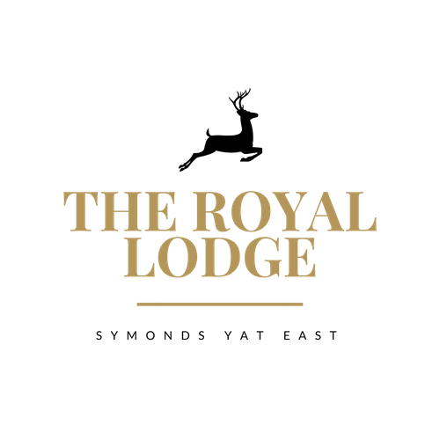

Dear Both,

Congratulations on your engagement and thank you for your valued enquiry to host your special day here with us here at The Royal Lodge, Symonds Yat East.

The Lodge has an idyllic setting in the heart of the Wye Valley, an area of outstanding natural beauty, where the river cuts through a wooded gorge on the edge of the spectacular Forest of Dean. The Lodge is nestled just below Symonds Yat Rock and stands exclusively in the grounds of almost 5 acres overlooking the river, the perfect setting for your special day.

The Lodge has an indoor function suite combined with a fantastic, raised lawn which is perfect for a marquee overlooking the River Wye. We also offer our fully licensed outdoor wooden pergola for your special ceremony with a difference.

In this pack you will find a sample of our wedding menus, should you have any special requirements for your menu please let us know, all dietary needs and requests are catered for. All of our menu offerings are homemade, where possible we use local produce.

The Lodge can offer discounted venue fees for mid-week weddings. Venue fees vary dependant on the elements chosen, numbers of persons attending as well as the time of day, day of the week & time of the year that you choose for your special day.

Additional services that can be arranged include –river cruises along the River Wye, group canoeing and music services such as bands or DJ’s.

Please call us to arrange an appointment with our in-house wedding co-ordinator, who would be delighted to show you around the venue to discuss your wedding details & requirements.

We look forward to hearing from you.

Wedding Packages Can Include:

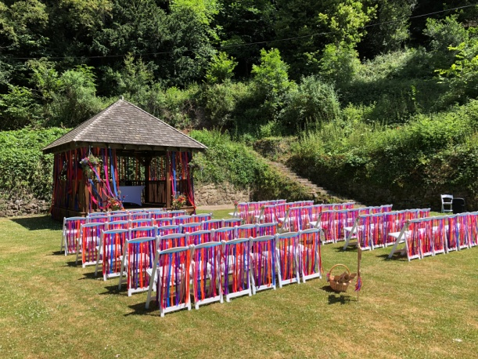
Exclusive or Non Exclusive Venue Hire

Ceremony – Choose either an outdoor or indoor
Ceremony

Banqueting Set up & Service Staff
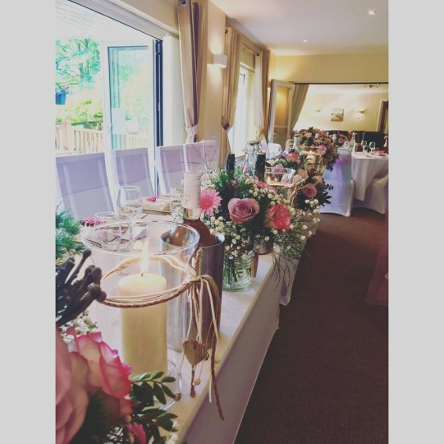
Welcome Drinks

Table Numbers & Name Cards

Three Course Wedding Breakfast

Organic Wine with Dinner

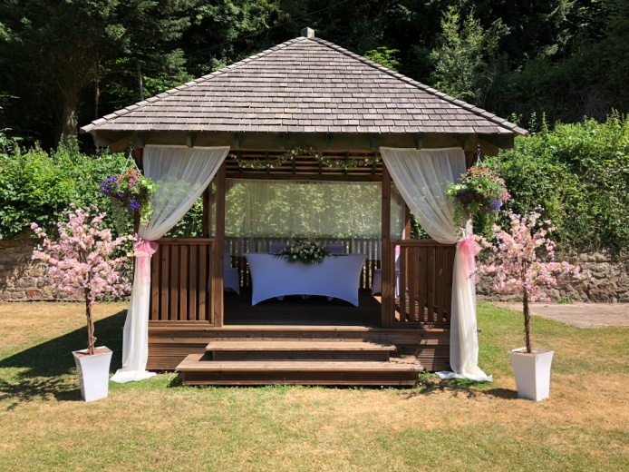
Organic Cava for Speeches

Chair Covers & Sashes – Charges Apply

Table Linen & Napkins – Charges Apply

For more information and prices please contact our wedding coordinator who will
Gladly assist you with a personalised quote.
Drinks Packages
Bronze £21.95pp
Pre-Reception Drinks
(served after the ceremony if held at The Royal Lodge or on arrival for church weddings)
Fruit Juice Selection & Filtered Bottled Water, Glass of Organic Wine served with Wedding Breakfast, Glass of Organic Cava for speeches
Silver £24.95pp
Pre-Reception Drinks
Organic Cava, Fruit Juice Selection & Filtered Bottled Water, Glass of Wine served with Wedding Breakfast, Glass of Organic Cava for speeches
Gold £29.95pp
Pre-Reception Drinks
Pimm’s & Lemonade, Fruit Juice Selection & Filtered Bottled Water, Two Glasses of Wine served with Wedding Breakfast, Glass of Organic Cava for speeches

Canapés from £14.95 pp
Min 20 Persons: Choose any three from below, upgrade to six additional £4.95pp:
Mini Rare Roast Beef Sandwich, Dijon Mustard and Rocket (M, W)
Chicken Liver Parfait with Red Onion Chutney (Sul)
Lamb Croquette (W, E)
Tandoori Chicken Filo Basket with a Red Onion Salad (W, M)
Cottage Pie Tartlet (W)

Smoked Mackerel Arancini, Aioli (F, M, Sul)
Sweet and Sour Prawns with Gem Lettuce Cups (Cr, M)
Whiskey Cured Salmon, Soda Bread and Lime (W, M, F)
Cod Fritters, Tartar Sauce and lemon (W, Sul, F)
Malaysian Crab Cake, Chilli Jam (Cr, S)
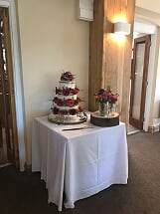
Apple and Sour Cream Rosti (Sul, M, E)
Baked Halloumi and Sweet Pepper Relish (Vegan)
Parmesan Shortbread with Beetroot Chutney (Sul, M)
Goats Cheese Stuffed Baby Tomato with Basil Leaves (Can be Vegan)
Baked Baby Potato with Sour cream and Chive (Can be Vegan)

Sample Bronze Menu £45.00 p.p
Based on min 30 persons, please choose 3 options for starter and main course to offer your guests

Bronze Starters
Pork and Spring Onion Momos with tomato, chilli and garlic chutney (W)
Chicken Liver Parfait with Date Puree, Toasted Focaccia and Pea Shoots (Sul, W,M, E)
Fig, Burrata and Prosciutto Bruschetta (W, Sul

Classic Royal Prawn Cocktail served simply with lemon salad and malted toast (Cr, W)
Smoked Mackerel Pate with melba toasts and lemon (F, W, Sul)
Salmon Fishcake with Horseradish Potato Salad (F, W)

Baked Feta With sesame, honey and warm pitta (Sul, W, E)
Heritage Tomatoes with a wasabi mascarpone, roasted seeds and rocket (W, Sul, M)
Garlic and Thyme Mushrooms in a filo pastry nest (W, M)

Bronze Main Courses
(All Served with mixed seasonal vegetables)
Roasted Supreme of Chicken with duck fat roasted potatoes, gravy and bread sauce (W, M)
Pressed Slow Cooked Belly of Pork with local cider sauce, Fondant Potato and Sauerkraut (M)
Braised Feather blade of Beef with Horseradish Mashed Potatoes and Red Wine Gravy (M)

Roasted Fillet of Salmon butter cooked fondant potato, fennel and hollandaise sauce (F, M)
Red Snapper Baked En Papillote Mediterranean Vegetables (F)
Pan Seared Seabass With saffron and crab potato cake, buttered greens and sapphire (F, E, M)

Portobello Mushroom, Leeks, Smoked Cheddar herb crumb and butter new potatoes (M, W)
Cauliflower and Spinach Ceylon Curry with onion + cumin bhaji and coriander rice
Three Cheese and Thyme Tartlets with caramelised onions, dressed leaves (W, M)

Bronze Desserts

Homemade White Chocolate and Baileys Cheesecake with a raspberry compote (W, M)
Lemon Posset with homemade shortbread (W, M)
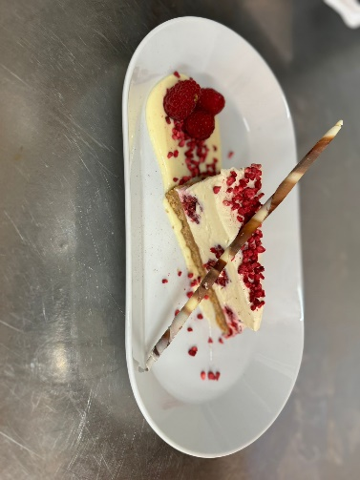
Lodge Strawberry Brulé with homemade shortbread (W, M)

Sample Silver Menu £50.00 p.p
Based on min 30 persons, please choose 3 options for starter and main course to offer your guests

Silver Starters
Anti Pasti Platter (M, W, Sul)
Crispy Lamb Shoulder Croquettes with smoked bacon aioli Pea Mousse (W, M)
Honey and Soy Duck Breast Charred Pak Choi, bean Sprouts (S, Sul)

Smoked Cod Scotch Egg with celeriac rémoulade and tomato aioli (F, M, E)
Tian of Crab and Avocado with baby rocket, dill and mustard dressing (Cr, M)
Thai Style Fishcake with mooli salad, sweet chilli, ginger and lime dressing (M, F)

Cauliflower Fritters with harissa aioli and pearl cous-cous (W, Sul)
Spinach and Feta Pancakes with chive hollandaise and pickled red onions (M, Sul)
Caramelised Shallot, Roasted Pepper and Brie Tartlet with green pepper coulis (M, W)

Silver Main Courses
(All Served with mixed seasonal vegetables)
Roast Sirloin of Beef with beef dripping roast potatoes, Yorkshire pudding and rich gravy (W)
Confit Duck Leg, clotted cream mashed potatoes, porcini mushroom & plum sauce (M, Sul)
Tandoori Lamb Shanks with masala potatoes and Indian salad (M, Sul)

Pan seared Salmon Fillet with braised puy lentils savoy cabbage and sauce vierge (F, M)
Pan Fried Fillet of Seabass with wild mushroom and cider cream sauce (F, M)
Asian Style Whole Baked Bream with sticky rice (Soy)

Moroccan Aubergine and Mushroom Cassoulet with cheddar cobbler and tender stem (M, W)
Hand Rolled Potato Gnocchi with Alfredo and Spinach Sauce (M, W)
Pesto and Goats Cheese Risotto (M)

Silver Desserts

Earl Grey Tea Infused Sticky Toffee Pudding, toffee sauce and vanilla bean ice-cream (W, M)
White Chocolate Crème Brulé with vanilla shortbread (M, W)
Tarte Au Citron with Raspberry Sorbet (M, W)
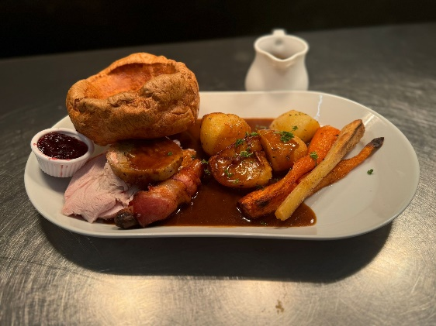

Sample Gold Menu £55.00 p.p
Based on min 30 persons, please choose 3 options for starter and main course to offer your guests

Gold Starters

Aged Beef Tartar With bocconcini, egg yolk and baby rocket (E, M)
Braised Ham Hock & Chicken Terrine with baby vegetables and tarragon mayonnaise (M, W)
Duck Salad with smoked lardons, orange gel and pomegranate dressing (Sul)

Beetroot and Gin Cured Gravlax Salmon, pickled radish, preserved lemon & flowers (F, Sul)
Tandoori Monkfish with dhal croquette, garlic and mint riata (M, W)
Seared Scallops with celeriac volente and baby watercress (Cr, M)

Twice Baked Goats Cheese Soufflé with toasted sourdough and tomato chutney (M, W, Sul)
Beetroot Gnocchi Sauté chanterelle mushrooms and spinach puree (W)
Vegetable Ravioli With vegetable garlic broth (W)

Gold Main Courses

Fillet Steak Tornados Rossini with madeira sauce and roasted baby vegetables (M)
Pan Roasted Breast of Guinea Fowl, pancetta bubble and squeak and cauliflower puree (M)
Dijon and Herb Crusted Lamb Rack with Roasted Jersey potatoes and mint salsa Verdi (W, M)

Roasted Loin of Cod with a white bean and chorizo cassoulet and crispy leeks (F, M)
Lightly Poached Crab Tortellini with crab velouté and lemon herbs (Cr, W, M)
Sri Lankan Monkfish Curry with coconut rice, tarka dhal & nan bread (W, M)

Wild Mushroom Risotto with truffle (M)
Caramelised Butternut Squash Ravioli with sage butter (W, M)
Pea and Mint Croquettes with roasted tender stem and cream mint sauce (M, W)

Gold Desserts

Chocolate Truffle Fondant with honeycomb ice-cream (M, W)
Apple Tart Tatin with salted caramel sauce and vanilla bean ice cream (M, W)

French Strawberry Tart with clotted cream and edible flowers (M, W)

Garden Menu
From £22.95 pp based on min 30 persons
Selection of homemade bridge rolls
Served on white and brown bread with the following fillings:

Egg mayonnaise & watercress
(E, M, W)
Mild cheddar & Sweet pickle
(SUL, M, W)
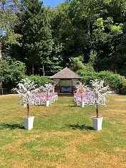
Honey Roast Ham & Mustard
(M, MU, W)
Smoked Salmon & Cream Cheese
(F, M, W)
Homemade Quiche’s
(MU, C, M, W, E, V)

Warm homemade Scones
(E, V, M, SUL, W)
Served with Strawberry Jam & Clotted Cream

Selection of delicious homemade Cakes:

Classic Victoria Sponge (SUL, M, W, E, V)
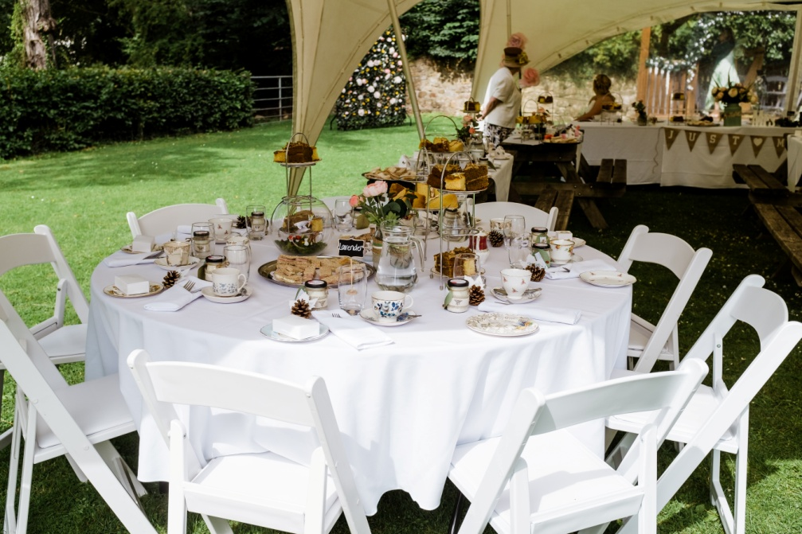
Lemon Drizzle (M, E, W)
Chocolate Brownie (M, W, E, V)

Garden additions

Garden Chairs £2.95 Each
Garden Gazebo £195 (size 3m x 5.40m)
Marquee £POA

Evening Buffet
From £19.95 pp based on min 30 persons
Please Choose One of the Below

Traditional Buffet (C, M, W, E, MU) £19.95

Assiette of Sandwich Platters on White and Granary Bread Served with Fresh Crudities, Dips, Jacket Wedges, Homemade Sausage Rolls, Royal Lodge Quiche, Potato Salad and Fragrant Fruity Couscous

Hot Meat’s Buffet (F, M, W, E) £21.95 pp

Roasted Pulled Pork Baps with Sage Stuffing and Apple Sauce, Roasted Turkey Baps with Cranberry Sauce. Beetroot and Chickpea Burgers, Potato Wedges, Breadsticks, Crudities and Selection of Dips

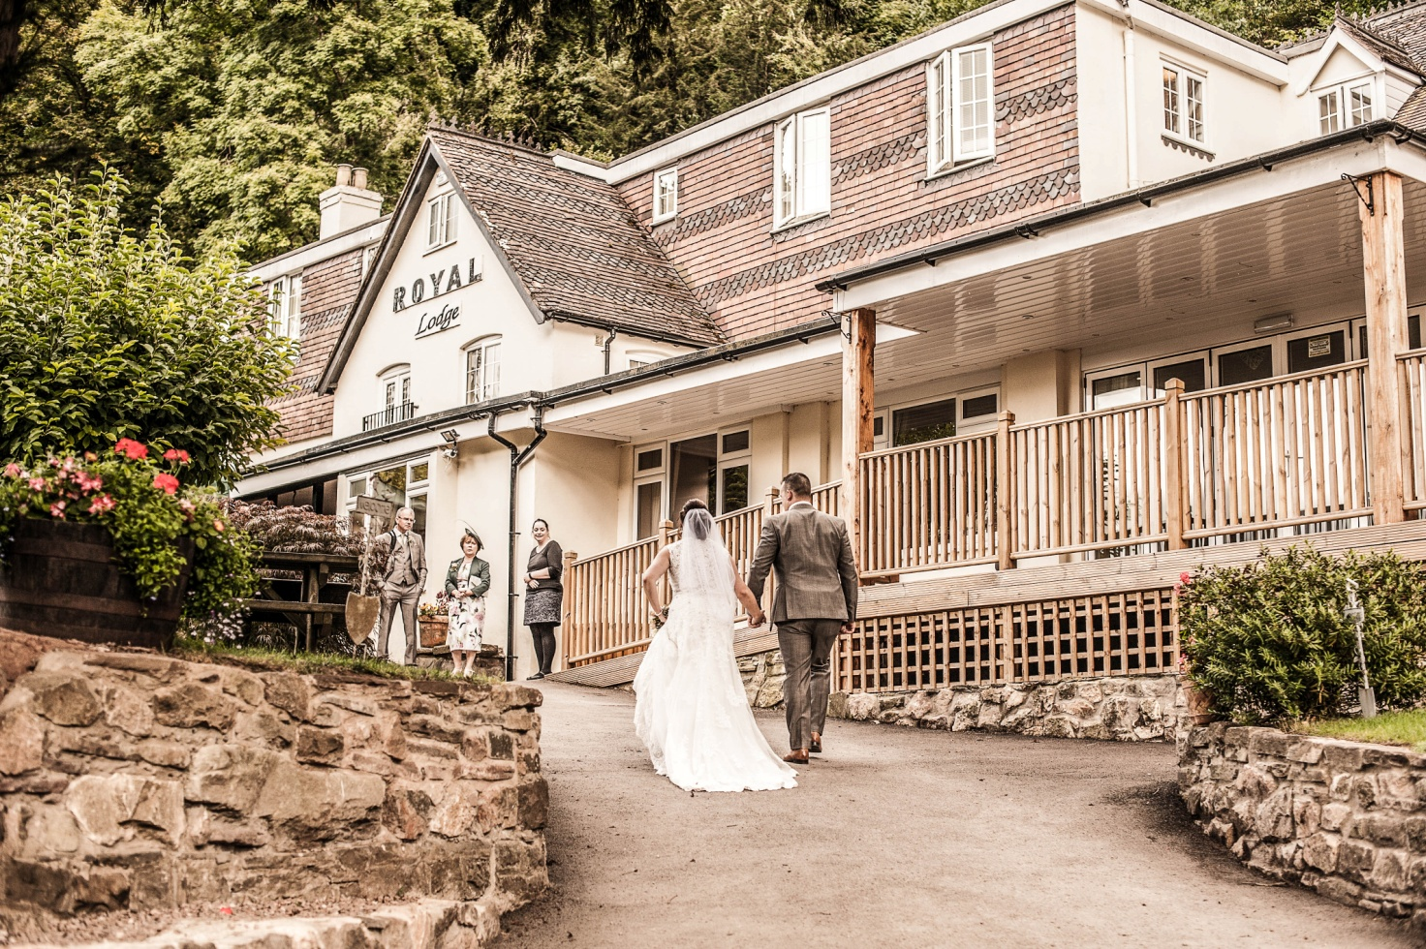

Evening Options
Fork Buffet Option 1 (C, W, E, M)
From £25.95 pp based on min 30 persons
Choose 2 options for Hot & 3 options for Cold, Salad and Dessert

HOT MEAT OPTIONS
Traditional Beef Lasagne (W, M)
Classic Cottage Pie (M)
Chicken Supreme, Cream Sauce (M)
Beef Bourguignon
Chilli Con Carne
HOT FISH OPTIONS
Creamy Mixed Fish Pie (F, M)
Salmon Fillet, Dill Sauce (F, M)
Thai Fish Cakes (Cr, W)
HOT VEGETABLE OPTIONS
Roasted Vegetable Lasagne (W, M)
Mushroom Stroganoff (M)
Goats Cheese & Polenta Tart (W, M)
COLD SECTION OPTIONS
Sliced Sirloin of Beef & Horseradish Cream (M)
Sliced Roasted Turkey & Cranberry Sauce
Honey Glazed Gammon
Coronation Chicken (M)
Butternut Squash and Goats Cheese Tart (W, M)
Red Onion & Brie Tart (M, W)
Poached Salmon & Watercress (F)
Chicken & Pesto
SALAD OPTIONS
Traditional Greek Salad (M)
Roasted Beetroot, Spinach and Rocket Salad
Coleslaw (M)
Potato Salad (M, W)
Tomato, Basil and Mozzarella Salad (M)
Vegetable & Feta Couscous (M)
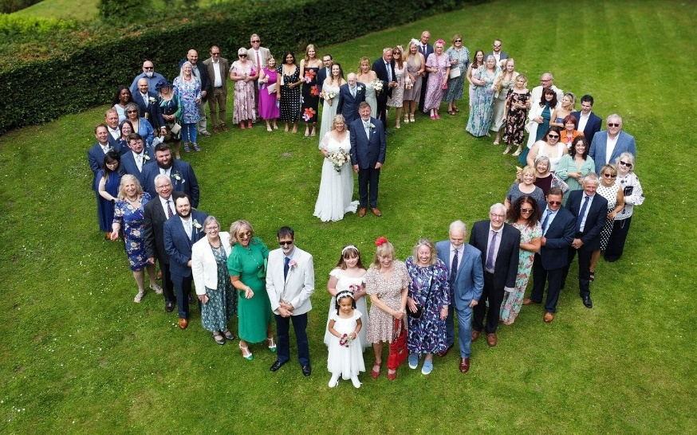
DESSERT OPTIONS
Spiced Apple Pie (W, M)
Mixed Fruit Crumble (W, M)
Profiterole & Chocolate Sauce (W, M)
White Chocolate Cheesecake (W, M)
Seasonal Fresh Fruit Salad
Treacle Tart (W, M)
Fork Buffet Option 2 (C, W, E, M)
From £29.95 pp based on min 30 persons
Choose 2 options for Hot & 3 options for Cold, Salad and Dessert

HOT OPTIONS
Lamb Korma Pots (W, M) Tandoori Chicken Chatt (M) Lamb Tawa Tikka (M)
Goan Pork Vindaloo (M) Rashain Kebabs, Spiced Sauteed Onions Chicken Jalfrezi
Balinse Slow Cooked Pork, Ginger, Chilli & Soy (So) Moroccan Lamb Tagine
Chilli Con Carne Lamb Kofta & Spiced Tomato Sweet and Sour Pork
Sri Lankan Monkfish Curry
HOT VEGETABLE OPTIONS
Paneer Methi Malai
Mushroom Masala
Gulta Curry
Onion Bahai (W)
Ginger & Chilli Tofu, Pak Choi (So)
COLD SECTION OPTIONS
Chicken Tikka Wings (M)
Sliced Turkey Chatt (M)
Moroccan Spiced Ham
Coronation Chicken (M)
Butternut Squash & Goats Cheese Tart (M, W)
Hoisin Pork Spareribs (So, S)
Bao Buns with Sticky Beef (W, S)
SALAD OPTIONS
Tomato, Onion & Coriander
Bombay Potato (M)
Roasted Hummus & Pitta (W)
Tabbouleh (W, M)
Waldorf Salad
Asian Slaw (So)
Traditional Greek Salad (M)
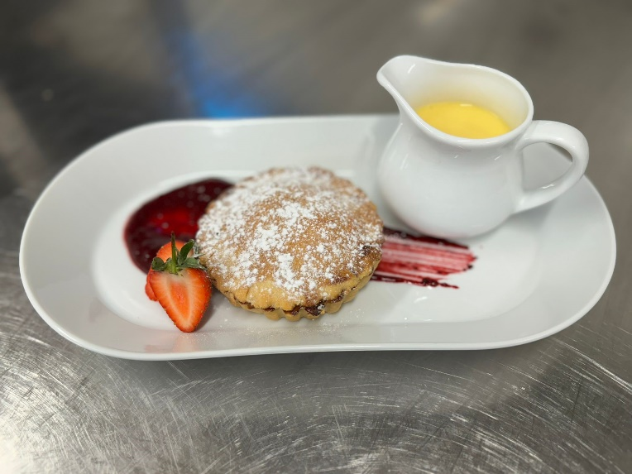
DESSERT OPTIONS
Guib Jamon (W, M)
Banana Fritters (W, M)
Tiramisu (W, M)
Baked Apple Pie (W)
Crème Brulé (M, E)
Daan Tat (W, E, M)

Lodge Hog Roast and BBQ (C, W, E, M)
From £29.95 pp based on min 60 persons

Local Herefordshire Pig Roast with Homemade Apple Sauce, Sage Stuffing, Seasonal Salad, Brioche Buns, Beef Burgers, Gourmet Sausages and Red Pepper & Halloumi Kebabs
All Served with Selection of Salads, Crudities and Dips

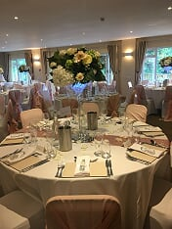
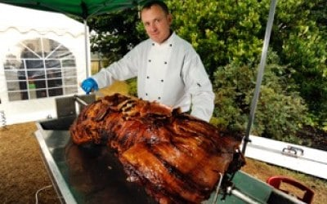

Selection of Soups Available
Seasonal Vegetable
Creamy Leek and Potato
Wild Mushroom
Plum Tomato and Fresh Basil
Mulligatawny

